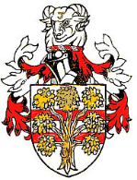WESTMORLAND LAW SOCIETY
In association with

CPD Event and breakfast meeting
at
The Villa, Levens, Kendal
Wednesday 4th October 2017
9am for 9.30am start (3 hours CPD)
£30 per person

Name: ……………………………… Firm:………………………………………...

Places at £30: ………………… Total: £……………………..
Please make your cheque payable to: Westmorland Law Society and send the second section of this form, together with your cheque to: Nicola Steadman, Secretary of Westmorland Law Society, Thomson Hayton Winkley, DX63410 Kendal, or 114-116 Stricklandgate, Kendal, LA9 4QA

Please return the form and payment by Wednesday 27th September 2017.
Email address:………………….…………………………………………………

